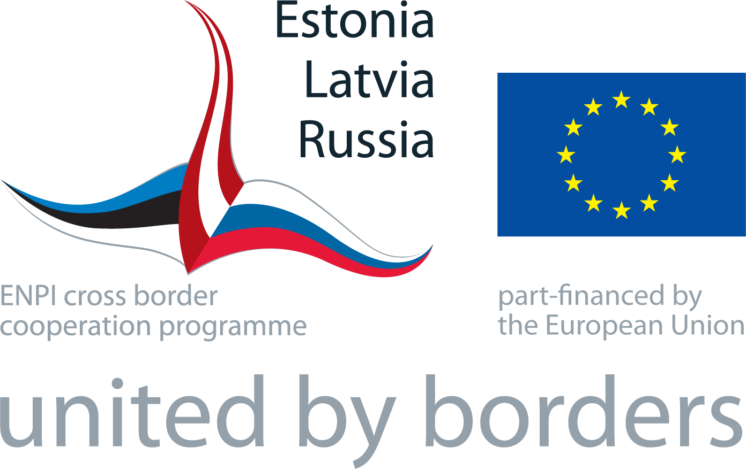 | PROGRAMME FINAL EVENT in ESTONIA  “MAGIC of CBC”  Vanemuine Concert Hall and AHHAA Science Centre  TARTU, ESTONIA  27-28 May, 2015

Time | Activity – DAY I , 27 MAY  VENUE – Vanemuine Concert Hall, Big Hall (Vanemuise 6, Tartu)
12.00 | Registration, welcome tea and coffee, snacks
PART I
Conference “MAGIC of CBC”
12:30 | First session of the conference puts focus on achievements, results and challenges of cross border cooperation within Estonia-Latvia-Russia Programme 2007-2013 with special attention to Programme Measure 2.1.  Opening and welcome words  Lecture - Borders and cooperation mechanism in Animal Kingdome by Mr Aleksei Turovski  Presentations on achievements of the cross border cooperation in Estonia-Latvia-Russia Programme – magic of CBC  Programme Measure 2.1 – Joint actions aimed at protection of environment and natural resources – benefit of CBC to greener and sustainable future
 | Entertainment
14:00 | LUNCH
 | PART II
15:00 | Second session of the conference concentrates on progress of preparation and perspectives of the Estonia-Russia Cross Border Cooperation Programme 2014-2020  Partnership and networking in focus  Questions and Answers
16:30  16:45 | CONCLUSIONS  CLOSING  Tea and coffee available

Project Award Ceremony
VENUE – AHHAA Science Centre (Sadama 1, Tartu)
19:00 -  22:00 | Gala dinner  Performance of Science Theatre of AHHAA Centre  Awarding ceremony  Live music
Time | Activity – DAY II, 28 MAY  PROJECT SITE VISIT in Tartu and Räpina
9:20  9:30  15:30 | Gathering at Vanemuine parking place (in front of Vanemuine Theatre in Ülikooli Street)  Departure by bus  Site visit to Tartu Environmental Education Centre (“People with Nature” project)  Site visit to Tartu Karlova Boat Port (“Common Peipsi” project)  Site visit to Räpina Centre for Creative Industries (“Promoting Heritage” project)  LUNCH and site visit in Räpina Boat Harbour (“Common Peipsi” project)  Bus trip from Räpina to Tartu  Arrival in Tartu Vanemuine parking place (in Ülikooli Street)

