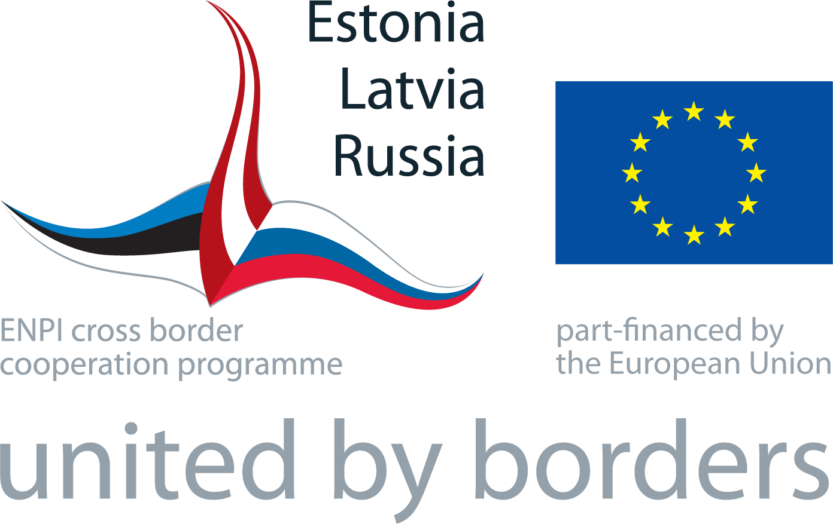 | ANNUAL EVENT  “Enjoy the Hansa route  through Latvia, Estonia and Russia!”  Conference Centre “White Grand Piano” and  Sigulda Castle of the Livonian Order  SIGULDA, LATVIA  10-11 June, 2013

Time | Activity – DAY I – 10 JUNE  VENUE – Conference Centre “White Grand Piano” (Šveices 19, Sigulda)
10.30 | Registration, welcome tea and coffee, snacks  PHOTO SHOW - ”Programme throughout 2012 and 2013”
PART I
Conference “Support to the Cross Border Cultural and Active Tourism in Latvia, Estonia and Russia”
11:00 | Moderator of the Conference - Mr Armands Slokenbergs, Director of the State Tourism Development Agency of Latvia, Tourism Person of the Year 2012 (awarded during BALTTOUR 2013)  WELCOME WORDS:  - Ms Dace Grūberte - Head of the Joint Managing Authority  - Mr Priidu Ristkok – Head of the Regional Development Department of the Estonian Ministry of the Interior  - Representative of the Ministry of Regional Development of the Russian Federation (tbc)
11:15  11:45 | „Role of Estonia-Latvia-Russia CBC Programme in the social-economic development of border regions: progress and achieved results” Ms Dace Grūberte, Head of the JMA  Progress of the ENI Programming 2014 - 2020:  - ENI Latvia-Russia CBC Programme – Ms Iruma Kravale, Director of Development Instruments Department, Ministry of the Environmental Protection and Regional Development  - ENI Estonia-Russia CBC Programme – Ms Silja Sorgus, Advisor, European Territorial Cooperation Bureau, Regional Development Department, Estonian Ministry of the Interior  - Perspective on the future ENI cross border cooperation with Latvia and Estonia Representative of the Ministry of Regional Development of the Russian Federation (tbc)
12:00  12:30 | "European Cultural Routes: Sustainable Network Management and their Socio-Economic Impact Evaluation." Ms Kseniya Khovanova-Rubicondo, Expert of the Council of Europe (Team Leader of the study of the Council of Europe - “Impact of European Cultural Routes on SMEs’ innovation and competitiveness”)  LUNCH
13:30  14:15  14:30  14:45  15:00  15:30  15:45  16:00 | Academic lecture: “Socio-economic development of the Hansa route through centuries” Dr.oec., Assoc. Professor Mr Viesturs Pauls Karnups, Univerisity of Latvia  Presentation of the thematic study – “The capital gathered by the Programme and its Tourism Projects during their implementation until the year 2013 and possible use of this capital for the ENI 2014-2020” - Unda Ozoliņa, Head of the Joint Technical Secretariat  Via Hanseatica Tourism Route – enhancing common cultural heritage of Latvia, Estonia and Russia Ms Sille Talvet, Project Manager of Via Hanseatica Project  Questions and Answers, interaction with the audience  Coffee Break  Role of tourism development in Pskov Oblast - Hansa Days 2013 in Pskov, Russia  Ms Olga Alexeeva, Head of Tourism Development Department, State Committee on Culture of the Pskov region, Pskov Oblast Administration (tbc)  Potential of the Brand “Hansa” - Mr Ēriks Lingebērzinš, representative of the tour operator “Via Hansa”  Lessons learned and future perspective – implementation results of the cross border tourism project “Enjoy Latvia, Estonia and Russia! Ms Linda Bēce, Project Manager of the Project “Enjoy Latvia, Estonia and Russia!”  Questions and Answers, interaction with the audience
16:30 | CONCLUSIONS

 | PART II - Project Site Visits (in parallel)
17:00 | Project Site Visits:  - Site Visit to Active Tourism Project “SVS Activetour” – visiting Skiing Track, opportunity to experience active tourism on climbing tower “Eža tornis” and adventure park “Mežakaķis”  (Guide – Ms Inga Zālīte, Director of Department for Development, Council of the Sigulda District, assisted by JTS representative (in Russian))  - Site Visit to the Tourism Project “Via Hanseatica” - Tourism INFO terminal and historical heritage of Sigulda (Gūtmaņa Cave and Turaida Castle)  (Guide – Ms Laura Konstante, representing partner in the Project, assisted by JTS representative).  - Site Visit to Nature Education and Tourism Project “People with Nature” – Pauguri Forest School in Līgatne Nature Park  (Guide – Ms Meldra Langenfelde, Project Manager, Nature Conservation Agency of Latvia, assisted by JTS representative)
19:30 | Networking, partner meetings, consultations - OPEN-AIR DINNER
Time | Activity – DAY II , 11 JUNE  VENUE – Sigulda Castle of Livonian Order (Pils iela 18, Sigulda)
8:30  9:50 | Arrival of Projects  Arrival of visitors  PHOTO SHOW - ”Programme throughout 2012 and 2013” (on big screen?)
PART III
Exhibition “Enjoy the Hansa Route through Latvia, Estonia and Russia!”
10:00 | Opening of the Open-Air Exhibition “Enjoy the Hansa Route through Latvia, Estonia and Russia!”  Open-Air Exibition “Enjoy the Hansa Route through Latvia, Estonia and Russia!” open to visitors  Guided Tour through the simulated Via Hanseatica Touristic Route and historical Hansa Cities every 30 minutes  Latvian national cuisine  Folkmusic
11:00 - 13:30  14:00 | Opportunity to play Petanque Game (Projects, JTS, JMA, NAs or mixed teams, visitors)  AWARDS  CLOSING

