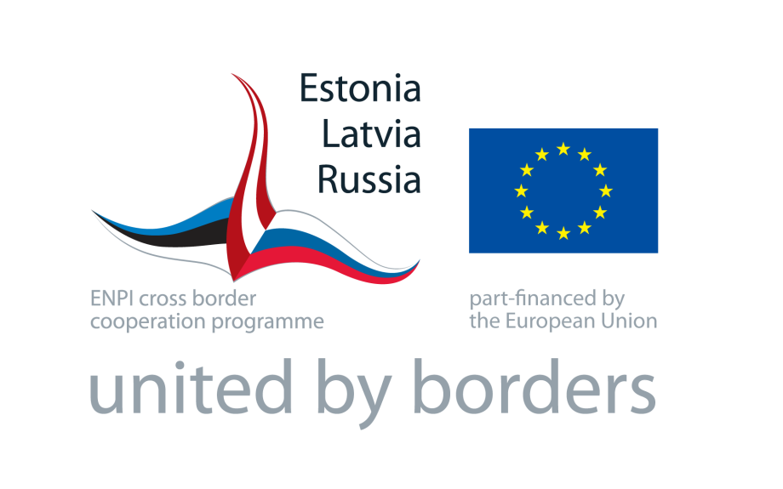

Estonia – Latvia – Russia Cross Border Cooperation Programme

within European Neighbourhood and Partnership Instrument

2007 - 2013

COMMUNICation and visibility

GUIDELINES

for the Projects selected within open call for proposals

TABLE OF CONTENT

- General Provisions ................................................................. | 3
- Programme Logo ................................................................... | 3
- Communication Tools ............................................................. | 4
- Press releases and press conferences .............................  - Press visits .................................................................  - Leaflets, brochures and newsletters ...............................  - Website .....................................................................  - Display panels ............................................................  - Commemorative plaques ..............................................  - Banners .....................................................................  - Vehicles, supplies and equipment ..................................  - Promotional items .......................................................  - Photographs ...............................................................  - Audio-visual production ................................................  - Public events and visits ................................................ | 4  5  5  5  6  6  7  7  8  8  9  9
- Reporting ............................................................................. | 9
- Programme visibility after completion of the project ................... | 9
ANNEXES
Annex 1 - Use of the Programme Logo
Annex 2 – Disclaimer, General Statements and Programme Title
Annex 3 – Press release template
Annexes 4.1;4.2;4.3 – Display panel templates in Latvian, Estonian and Russian languages
Annexes 5.1;5.2;5.3 – Commemorative plaque templates in Latvian, Estonian and Russian languages
Annexes 6.1;6.2;6.3 – Informational poster templates in Latvian, Estonian and Russian languages

- General Provisions

Communication and Visibility Guidelines (hereinafter Guidelines) contains compulsory requirements for projects, supported by the Estonia – Latvia – Russia Cross Border Cooperation Programme within European Neighbourhood and Partnership Instrument 2007 – 2013 (hereinafter Programme) that have been selected within open Call for Proposals, in order to ensure visibility of projects activities and results.
These guidelines are based on the Communication and Visibility Manual for EU External Actions, 2010 (hereinafter Manual) published by the European Commission. The Manual is available to download on the Europe Aid website at: http://ec.europa.eu/europeaid/work/visibility/documents/communication_and_visibility_manual_en.pdf.
As the Programme is co-financed from the European Neighbourhood and Partnership Instrument (ENPI), and having received the funding from the Programme, project must acknowledge and promote this.
Main objectives of the information and publicity activities at the projects supported by the Programme are following:
• To highlight in a dynamic way that the project is supported by the Programme and to promote cross-border cooperation and its results;
• To ensure transparency in the use of public funds assuring the wider public that Programme co-financing has been put to good use.

Communication and visibility activities within the project have to be implemented accordingly to the project Activity Package 2 – Information and Visibility, which is part of the project Grant Application Form (a document, which was filled in when a proposal for the Project was submitted).
Please note that:
If the publicity requirements are not observed or only partly observed, the related costs are not eligible for Programme co-financing.

Programme Logo

The Programme logo is main visual element of the Programme and has to be used in all communication activities performed by the beneficiaries and project partners.

The Programme logo consists of 3 integral elements:
- the EU flag - main EU visual identity element,
- visualised flags of the 3 participating countries – Estonia, Latvia, Russia,
- text with explanations and the Programme slogan “United by borders”.

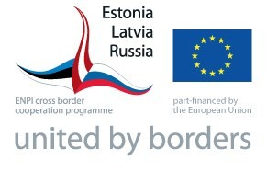

The Programme logo always shall be used as one united graphic element consisting from all 3 parts described above. The Programme logo cannot be divided into separate parts. The smallest allowed size for the Programme logo use is 40x25 mm (Annex 1, Figure 1 and 2).

Only exception when the Programme logo can be used in its simplified version is in cases if it is printed on the small items, and if the printed logo version is smaller than 40x25 mm. However, the minimal size of the simplified logo version is 20x8 mm (Annex 1, Figure 3 and 4).

Use of the Programme logo is compulsory on all the communication materials and tools (both hard copy and electronic), project documents and all outputs produced by the project.

The Programme logo can be used in 2 versions:
- colourful (Annex 1, Figure 1 and 3),
- black & white (Annex 1, Figure 2 and 4).

The Programme logo preferably should be printed on a light background. Multicolour backgrounds should be avoided, especially those involving colours clashing with the Programme logo colours.

If the Programme logo is used together with other logos or emblems, the Programme logo has to be at least the same size as the other emblems being used.

The Programme logo is available for download at the Programme website: http://www.estlatrus.eu/eng/programme/publications_amp_logo

In case the Project designs its own corporate identity, i.e. letterheads, business cards, presentations templates etc., it must include the Programme logo.

- Communication Tools

Communication activities can be implemented using different tools listed below, but if appropriate, other communication tools can be used.

Before choosing what particular communication activities to use, it is important to think over what kind of activity it should be. Only after that the means and channels of communication can be chosen that suit the character of the action best. Communication activities should be attractive, creative and innovative, but also simple and cost-effective. It is recommended to use every opportunity to inform about project’s major activities and achievements.

Electronic templates have been developed for various types of communication tools and can be downloaded from the Programme web-site:
http://www.estlatrus.eu/eng/programme/publications_amp_logo

  - Press releases and press conferences

Press release should incorporate the Programme logo, the Programme statement (Annex 2, point 2) and in the text mention that the funding was provided by the Programme and what is the amount of Programme co-financing in euro and in the local currency. If the specific project logo is designed, it can be used in the press release (see template in Annex 3).

The press release should be sent at least initiating and finalising the project, as well as prior any major activity, event, news, result of the project.

A newsworthy press release should contain: an attractive heading, a strong leading paragraph summarising the essential facts, few quotes, some background information and contact details for further information. The press release should not be longer than one A4 page.

The project should inform the Joint Managing Authority (hereinafter JMA) and Joint Technical Secretariat (hereinafter JTS) about planned press conferences well in advance. Invitations to the press conferences and materials distributed to the journalists should bear the Programme logo and general statement about the Programme. The small Programme flag should be displayed at the press conference and preliminary obtained from the JTS or ordered.

The Programme flag should incorporate the Programme logo, which is available for download at the Programme website:
http://www.estlatrus.eu/eng/programme/publications_amp_logo

The Programme logo should cover the size of the Programme falg.

The small Programme flag should be designed as following:

- the Programme logo is printed on white background (paper or cloth);

- the flag is fixed on wooden or aluminium tang;

- the size of the flag is 137x280mm

The EU flag should be displayed if other flags or symbols being displayed.

3.2 Press visits

Group visits by journalists to the project sites may offer additional visibility opportunities. Such visits should be well-timed and focus on tangible achievements.

The JMA and JTS should be informed well in advance about such planned visits and where appropriate, groups of visiting journalists should be accompanied by representatives of the JMA and/or JTS.

3.3 Leaflets, brochures and newsletters

Publications always should be adapted to the specific target group needs and interests. The publications should focus on the project results and benefits. Texts should be kept short and informative, and the visual tools used to illustrate the publications content and make it visually attractive.

Electronic or printed publications such as leaflets, brochures, newsletters, studies, analyses, documents, articles, etc must display the Programme logo and the Disclaimer (Annex 2 point 1) to be placed on the cover or title page. On digital information carriers the Programme logo has to be placed on the front page, and also on the packaging (e.g. packaging of a CD).

All leaflets and brochures should incorporate:
- the full set Programme Logo,
- the front page lower banner must carry the disclaimer stating that the project is co-financed by the Estonia – Latvia – Russia Cross Border Cooperation Programme within European Neighbourhood and Partnership Instrument 2007 – 2013 and Programme participating countries, alongside with the European Union are not responsible for the content of these publications (see precise wording in Annex 2 point 1),
- the general statement of the Programme (see Annex point 2),
- the project details - contact name, address, telephone, fax and e-mail info.

All materials produced in paper form should also be made available in electronic form, so that it can be sent by e-mail and posted on a web site. For material in paper form, distribution capacity (mailing lists) should be considered.

Copies of all the paper and electronic publications should be made available to the JTS.

3.4 Website

The Project either may have its own web site (if the project will have significant material that could be communicated on a website) or publish its materials on the existing websites of the beneficiary and project partners. The website should contain information about the project, its progress, contact data, project achievements and results.

The Programme logo and disclaimer (Annex 2 point 1) shall be published on the home page of the website.

As a minimum, links should be made to:

- the Programme website: http://www.estlatrus.eu

- the EuropeAid Co-operation Office webpage: http://ec.europa.eu/europeaid/index_en.htm.

If in the website is published an article about the project, the Programme logo and disclaimer (Annex 2 point 1) shall be published in the same window as the article.

At the end of the project, the content of the web-site should be copied onto optical disc, such as CD or DVD or reliable solid-state devices, especially the USB flash drive and transmitted to the JTS for possible use in its general communication activities and for archival purposes.

3.5. Display panels

Infrastructure-related projects co-financed by the Programme may be identified as such by means of display panels describing the project. The display panels should be erected beside access routes to the site where the project is taking place, be clearly visible and should remain in place from the start of the project until at least six months after its completion.

If upon financing infrastructures or construction work the total contribution of the Programme exceeds EUR 100,000 for the infrastructure object, the display panel shall be erected in the location of the object.

Display panels should incorporate (see templates in Annexes 4.1;4.2;4.3):
- the Programme logo, which shall cover at least 50% of the area of the display panel,
- a phrase “This project is co-financed by the Estonia – Latvia – Russia Cross Border Cooperation Programme within European Neighbourhood and Partnership Instrument 2007 – 2013”,
- Name of the Beneficiary, title of the project,
- start/end time of the works.

The written information on the panel should be in official language of the respective Participating country. The minimum size of the display panel shall be 1,500 x 1,000 mm. The display panel may also bear the logos of other institutions associated with the finishing and financing of the object, and other additional information about the object.

Beneficiaries and project partners should also produce a display panel with which to promote their Programme co-financed project at an exhibition or event, or at the entrance of a training centre or office reception. The shape, size and dimensions of panels vary depending on the amount of information that needs to be conveyed, and whether the panel is intended to be portable or permanent.

3.6. Commemorative plaques

Permanent commemorative plaques are an effective way of acknowledging the involvement of the Programme in the construction or planning of permanent structures such as institutions, training centres, roads, bridges, etc.

If upon acquisition of a physical object or upon financing of infrastructures or construction work the total contribution of the Programme exceeds EUR 100,000, the Beneficiary and project partners shall within six months of the acquisition of the object or completion of the work at the latest place a commemorative plaque in the location of the object. Upon financing of infrastructures or construction work, the Beneficiary shall replace the display panel mentioned in section 3.5 with a commemorative plaque within six months of the completion of the work.

The commemorative plaques (see templates in Annexes 5.1;5.2;5.3) should incorporate:
- the Programme logo, which shall cover at least 50% of the area of the commemorative plaque,
- the phrase “This [name of the structure] was co-financed by the Estonia – Latvia – Russia Cross Border Cooperation Programme within European Neighbourhood and Partnership Instrument 2007 – 2013”,
- the date on which the object was finished.

The written information on the plaque should be in official language of the respective Participating country. The minimum size of the commemorative plaque shall be 500 x 300 mm.

The commemorative plaque installed shall be maintained at least until 31 December 2025.

As part of the opening ceremony of permanent structures erected with support of Programme co-financing, the permanent plaque should be placed in the most visible part of the building.

3.7 Banners

Plastic or textile banners incorporating the Programme logo and phrase “Project is co-financed by the Estonia – Latvia – Russia Cross Border Cooperation Programme within European Neighbourhood and Partnership Instrument 2007 – 2013” should be produced when specified in the information and publicity activities. They are intended to serve as a backdrop for various public events.
A banner is also an image shown on a webpage for advertising purposes. Banner can include as an additional visual element on a project’s website, as well as place it on other websites to promote projects and the Programme.

3.8 Vehicles, supplies and equipment

Any Programme co-financed vehicles, supplies and equipment used in the Project should be clearly identified, and visibly carry:
- the Programme logo,
- the phrase "Provided with the support of the Estonia – Latvia – Russia Cross Border Cooperation Programme within European Neighbourhood and Partnership Instrument 2007 – 2013" in English and in the official language of the respective Participating country.
The logos of the Beneficiary and project partners may also appear, although the Programme logo should be displayed at least as prominently as the logos of all parties involved in the project.

The JTS will provide project beneficiaries with the Programme stickers. The beneficiaries will be in charge distributing the Programme stickers to all relevant project partners. The Programme stickers will be available in two different sizes:
- small stickers - for smaller objects (office equipment, furniture items, smaller work tools etc.),
- large stickers – for larger objects (equipment, vehicle etc.).

Stickers will be distributed free of charge by the JTS accordingly to the proven needs of the project.

In case if premises are renovated or furnished with support of the Programme co-financing, and placing a display panel or commemorative plaque is not required, it is advised to put an informational poster in the room, institution or site where works have been done. Similarly, the informational poster should be placed in the premises where many small items are purchased in the framework of the project and it’s not possible to mark all the purchases. The poster must be placed in a visible location of these buildings, rooms, facilities or in place related to these. In case of the information sign, separate stickers do not have to be used to mark single objects.

The informational poster (see templates in Annexes 6.1;6.2;6.3) shall incorporate:
- the Programme logo,
- name or short description of the object financed by the Programme co-financing,
- the period of the project or the completion date.
The written information on the panel should be in official language of the respective Participating country.

3.9 Promotional items

The promotional items produced (such as T-shirts, caps, pens, etc.) should be clearly identified with the Programme logo and, if possible, carry the words " Provided with the support of the Estonia – Latvia – Russia Cross Border Cooperation Programme within European Neighbourhood and Partnership Instrument 2007 – 2013" and slogan of the Programme “United by borders”.

Should the project choose to design its own corporate identity (letterheads, business cards, presentation templates etc.) at least the Programme logo must be included in these materials.

On certain small promotional items (e.g. pens, USB flashes etc.) where it is not possible to include the full Programme logo and the key messages entirely, at least the smallest version of the Programme logo should appear (Annex 1, Figure 3 and 4).

Design of all the promotional and corporate identity items should be developed in cooperation with the Programme JTS.

Samples of the promotional items and corporate identity should be made available for the JTS.

3.10 Photographs

Photographs showing the progress of all actions should be taken where appropriate to document the progress of the project and during events related to the project. Where appropriate, the Programme logo, flag, banner and other elements of visual identity should appear in the photographs taken.

The project beneficiary and partners must ensure that photographs are in good quality and afterwards can be used in various communication materials and for reporting purposes. The photos should illustrate results and impact of the project, and should match any written information about the project.

As a general rule, digital photography should be used in order to facilitate reproduction on web sites and other information material (for producing printed materials, 300 dpi is the minimum quality standard).

Photographs also can serve as the proof of the activities carried out and have to be attached to the project reports submitted to the JMA. Duplicates of the photographs should be integral part of the project reports.

3.11 Audio-visual productions

As with all material, the audio-visual productions should acknowledge the Programme co-financing, by featuring the Programme logo at the beginning and/or end of the audio-visual file.

Any audio-visual production produced by the project must be integral part of the project reports.

3.12 Public events and visits

Organising public events such as conferences, workshops, seminars, fairs, exhibitions and others may offer excellent opportunities for generating interest in the project particular achievements.

Persons attending the Programme co-financed public events should be made aware that the Programme is co-financing the event. The Programme logo should appear on all the materials.

Depending on the circumstances, the opportunity should be taken to display the EU flag, Programme stand (can be obtained at JTS) and/or banners with the Programme logo in the meeting rooms.

The small Programme flag shall be used in all the public events organised by the beneficiary and partners. The small Programme flags can be obtained from the JTS free of charge.

The JMA and JTS have to be timely informed about the major events organized within the project in order to ensure their possible participation and contacts with media.

- Reporting

Beneficiaries and/or project partners are required to produce interim reports to update and inform the JMA and JTS on the progress and findings of the projects. In the front covers of these, the name of the project and the date of the report’s submission should be given. The front cover should contain Programme’s logo. The report’s back cover should contain the following disclaimer in the following wording:
“The contents of this publication are the sole responsibility of <name of the author/beneficiary/project partner> and can in no way be taken to reflect the views of the Estonia – Latvia – Russia Cross Border Cooperation Programme within European Neighbourhood and Partnership Instrument 2007 – 2013 and Programme participating countries, alongside with the European Union”.
Beneficiaries and project partners should make sure that at least one section of their reports contains detailed description and evaluation of their communication activities (giving concrete examples) and their impact (illustrating this with a file of press cuttings, photographs and audio-visual transcripts whenever possible).

5. Programme visibility after completion of the project

Project may continue to be managed by the Beneficiary or project partner after the Programme co-financed phase of the project has been completed. In this case, six months after the phase co-financed by the Programme has finished, no Programme symbol may be included in any communication tools of the project, with the exception of any commemorative plaques.
However, the following sentence must be included on communication tools: "The initial phase <dates> of <name of the project> was supported by the Estonia – Latvia – Russia Cross Border Cooperation Programme within European Neighbourhood and Partnership Instrument 2007 – 2013".
ANNEX 1

Use of the Programme Logo

All versions of the Programme logos you can download at the Programme web-site:
www.estlatrus.eu/xxxx

Colour version | Black and white version
Figure 1  Full set Programme logo  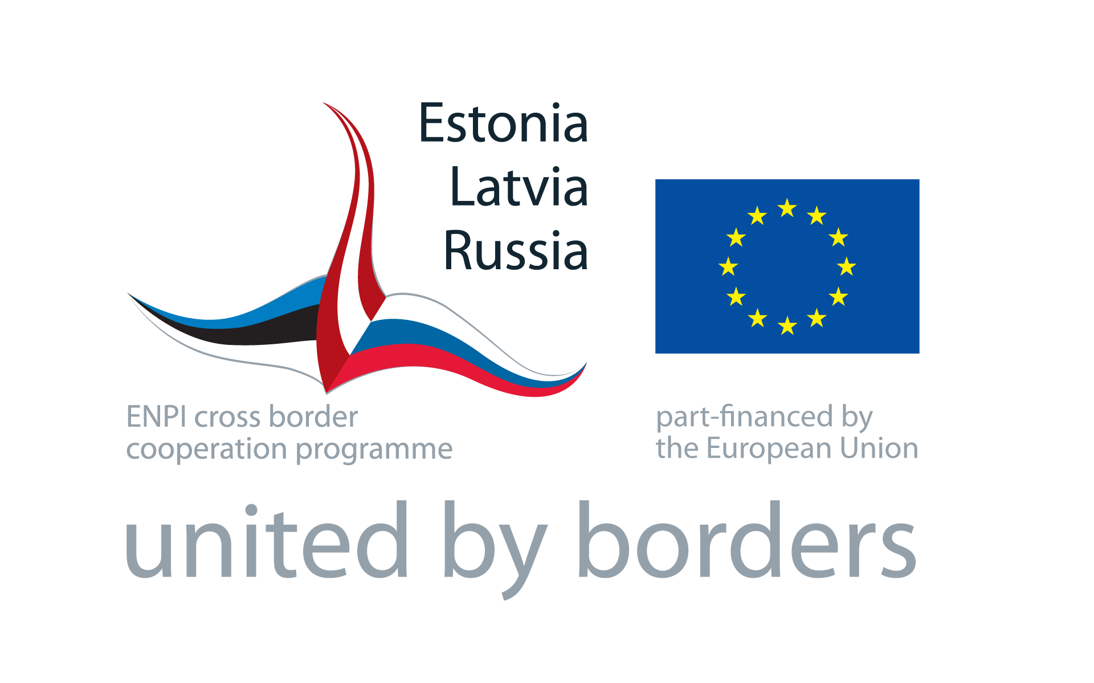  Recommended minimum size 40 x 25 mm. | Figure 2  Full set Programme logo  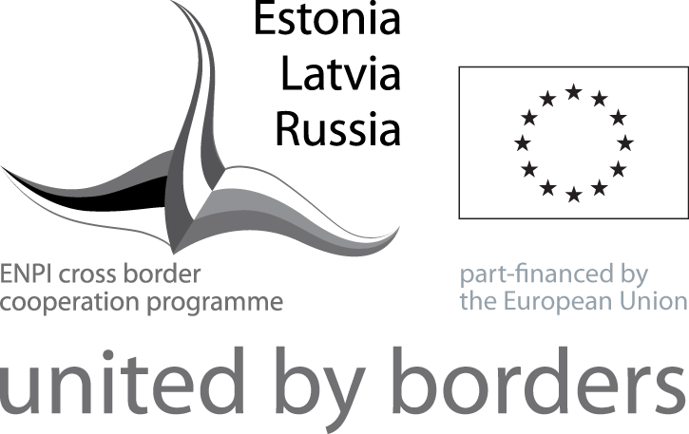  Recommended minimum size 40 x 25 mm
Figure 3  Programme Logo for small size products    Recommended minimum size 20 x 8 mm. | Figure 4  Programme logo for small size products  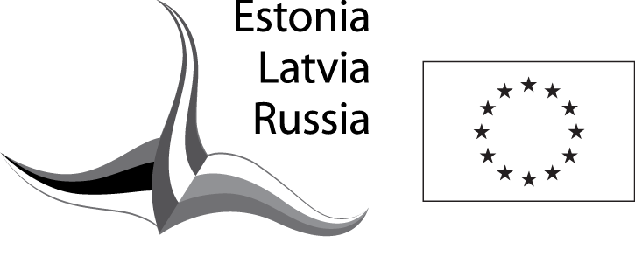  Recommended minimum size 20 x 8 mm.

ANNEX 2

Disclaimer, General Statements and Programme Title

- DISCLAIMER
Estonia – Latvia – Russia Cross Border Cooperation Programme within European Neighbourhood and Partnership Instrument 2007 – 2013 and Programme participating countries, alongside with the European Union are not responsible for the contents of communication material prepared by contractors or implementing partners. These must therefore include the following disclaimer in any of the project publications:

“This document has been produced with the financial assistance of the Estonia – Latvia – Russia Cross Border Cooperation Programme within European Neighbourhood and Partnership Instrument 2007 – 2013. The contents of this document are the sole responsibility of <Beneficiary’s or project partner's name> and can under no circumstances be regarded as reflecting the position of the Programme, Programme participating countries, alongside with the European Union.”

- GENERAL STATEMENT ABOUT THE PROGRAMME
“Estonia – Latvia – Russia Cross Border Cooperation Programme within the European Neighbourhood and Partnership Instrument 2007-2013 financially supports joint cross border development activities for the improvement of the region’s competitiveness by utilising its potential and beneficial location on the crossroads between the EU and Russian Federation.
The Programme web-site is www.estlatrus.eu.”

- GENERAL STATEMENT ABOUT THE EUROPEAN UNION
“The European Union is made up of 27 Member States who have decided to gradually link together their know-how, resources and destinies. Together, during a period of enlargement of 50 years, they have built a zone of stability, democracy and sustainable development whilst maintaining cultural diversity, tolerance and individual freedoms. The European Union is committed to sharing its achievements and its values with countries and peoples beyond its borders.”

- TITLE OF THE PROGRAMME
“Estonia – Latvia – Russia Cross Border Cooperation Programme within the European Neighbourhood and Partnership Instrument 2007-2013”

ANNEX 3
Press release template

THE BENEFICIARIES / PROJECT PARTNER REGULAR LETTERHEAD

Estonia – Latvia – Russia Cross Border Cooperation Programme within the European Neighbourhood and Partnership Instrument 2007-2013 financially supports joint cross border development activities for the improvement of the region’s competitiveness by utilising its potential and beneficial location on the crossroads between the EU and Russian Federation.
The Programme web-site is www.estlatrus.eu.

ANNEX 4.1
Display panel template for Latvia

[PROJEKTA LOGO un/vai FINANSĒJUMA SAŅĒMĒJA UN PROJEKTA PARTNERU LOGO]

Projekts līdzfinansēts no Igaunijas – Latvijas – Krievijas Pārrobežu sadarbības programmas
Eiropas Kaimiņattiecību un partnerības instrumenta ietvaros 2007. – 2013. gadam

Finansējuma saņēmēja un projekta nosaukums
Projekts tiek realizēts no xx.xx.xxxx līdz xx.xx.xxxx

PROJECT LOGO AND/OR BENEFICIARIES AND PROJECT PARTNERS LOGOS (optional)

ANNEX 4.2
Display panel template for Estonia

[PROJEKTI LOGO JA/VÕI TOETUSESAAJA JA PROJEKTIPARTNERI LOGOD ]

Projekti kaasrahastab Euroopa naabrus - ja partnerlusinstrumendi Eesti-Läti-Vene
piiriülese koostöö programm 2007-2013

Toetusesaaja ja projekti nimi
Projekt viidi ellu xx.xx.xxxx - xx.xx.xxxx

PROJECT LOGO AND/OR BENEFICIARIES AND PROJECT PARTNERS LOGOS (optional)

ANNEX 4.3
Display panel template for Russia

[ЛОГОТИП ПРОЕКТА И/ИЛИ ЛОГОТИПЫ БЕНЕФИЦИАРОВ И ПАРТНЕРОВ ПРОЕКТА]

Этот проект софинансируется Программой Приграничного Сотрудничества
«Эстония – Латвия – Россия» в рамках Европейского Инструмента Соседства и Партнерства 2007-2013
Бенефициар и название проекта
Проект введен в действие с xx.xx.xxxx по xx.xx.xxxx

PROJECT LOGO AND/OR BENEFICIARIES AND PROJECT PARTNERS LOGOS (optional)

ANNEX 5.1
Commemorative plaque template for Latvia

[Objekta nosaukums] līdzfinansēts no Igaunijas – Latvijas – Krievijas Pārrobežu sadarbības programmas
Eiropas Kaimiņattiecību un partnerības instrumenta ietvaros 2007. – 2013. gadam

PROJECT LOGO AND/OR BENEFICIARIES AND PROJECT PARTNERS LOGOS (optional)
Projekta ieviešana pabeigta xx.xx.xxxx

PROJEKTA LOGO un/vai FINANSĒJUMA SAŅĒMĒJA UN PROJEKTA PARTNERU LOGO
(pēc izvēles)

ANNEX 5.2
Commemorative plaque template for Estonia

[Objekti nimi] kaasrahastas Euroopa naabrus- ja partnerlusinstrumendi Eesti-Läti-Vene piiriülese koostöö programm 2007-2013

PROJECT LOGO AND/OR BENEFICIARIES AND PROJECT PARTNERS LOGOS (optional)
Projekt lõppes xx.xx.xxxx

PROJEKTI LOGO ja/või TOETUSESAAJA JA PROJEKTIPARTNERI LOGOD
(vastavalt soovile)

ANNEX 5.3
Commemorative plaque template for Russia

Объект [название строения] софинансировался Программой
Приграничного Сотрудничества «Эстония – Латвия – Россия»
в рамках Европейского Инструмента Соседства и Партнерства 2007-2013

PROJECT LOGO AND/OR BENEFICIARIES AND PROJECT PARTNERS LOGOS (optional)
xx.xx.xxxx проект был завершен

ЛОГОТИП ПРОЕКТА И/ИЛИ ЛОГОТИПЫ БЕНЕФИЦИАРОВ И ПАРТНЕРОВ ПРОЕКТА (на выбор)

ANNEX 6.1
Informational poster template for Latvia

Programmas līdzfinansējuma saņēmušā objekta nosaukums vai īss apraksts
Projekta periods vai beigu datums

ANNEX 6.2
Informational poster template for Estonia

Programmist kaasrahastatud objekti nimi või lühikirjeldus
Projekti periood või projekti lõppemise kuupäev

ANNEX 6.3
Informational poster template for Russia

Название или короткое описание объекта, софинансируемого Программой

Период проекта или дата завершения проекта

Contacts:

Vineta Šnore

Joint Technical Secretariat
State Regional Development Agency of the Republic of Latvia
Adress: Ausekļa Street 14 -3 (3rd floor), LV-1010, Riga, Latvia
Phone: +37167509526
E-mail: vineta.snore@estlatrus.eu

Liane Rosenblatt
Branch Office in Tartu, Estonia - only for Lõuna-Eesti and Kesk-Eesti areas
Phone: +372 738 6011
E-mail: liane.rosenblatt@estlatrus.eu
Sõbra 56, 51013, Tartu, Estonia
Artur Viira
Branch Office in Jõhvi, Estonia - only for Kirde-Eesti and Põhja-Eesti areas
Phone: + 372 339 5609
E-mail: artur.viira@estlatrus.eu
Pargi 27, 41537, Jõhvi, Estonia
Sergey Balanev
Branch Office in St. Petersburg, Russia
Phone: + 7 812 325 83 51
E-mail: sergey.balanev@estlatrus.eu
Izmailovsky Prospect 14, Office 316, St. Petersburg, Russia
Vladimir Skorokhodov
Branch Office in St. Petersburg, Leningrad Region, Russia
Phone: + 7 812 325 51 84
E-mail: vladimir.skorokhodov@estlatrus.eu
Izmailovsky Prospect 14, Office 314 A, St. Petersburg, Russia
Ekaterina Moskaleva
Branch Office in Pskov, Russia
Phone: + 7 81 12 79 40 54
E-mail: ekaterina.moskaleva@estlatrus.eu
Sovetskaya Street 60a, p.3, 4th floor, Pskov, Russia

