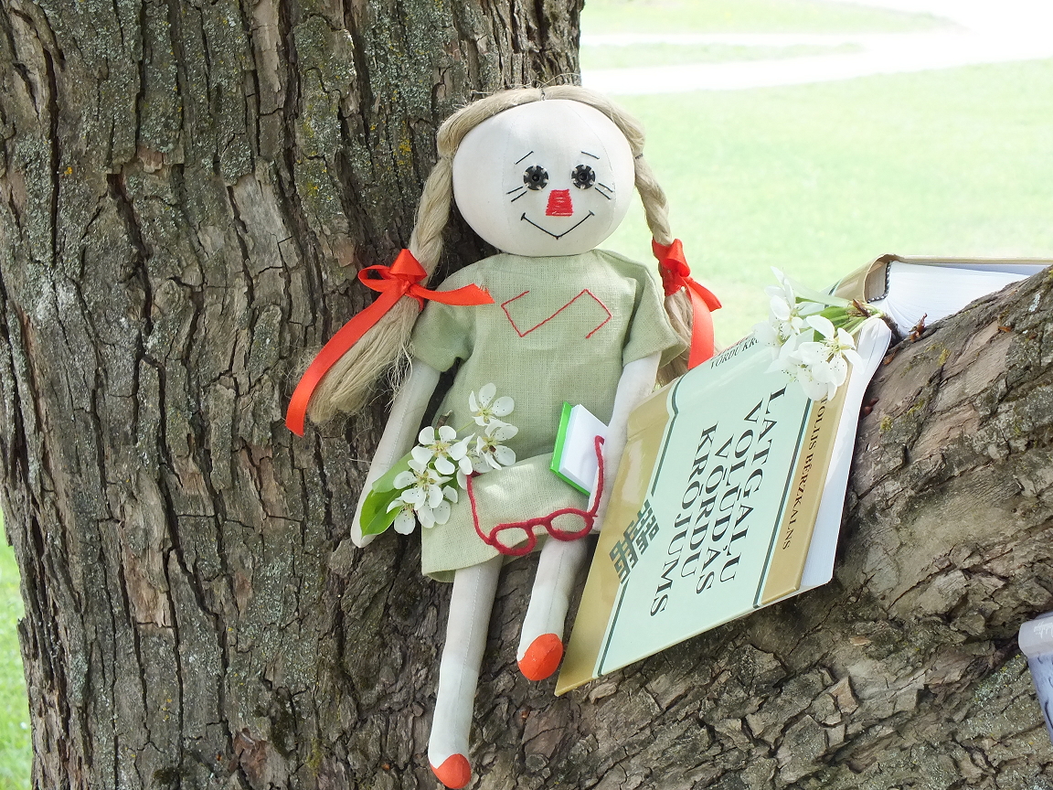
Shaping of Latvia-Russia border municipalities united cultural information place and cooperation network by means of literary artistic creative potential

Forget a Hurry

Priority 3 Promotion of people to people cooperation
Measure 3.2 Cooperation in spheres of culture, sport, education, social and health
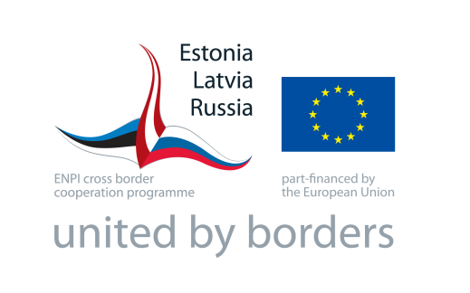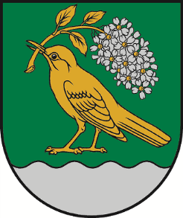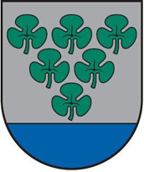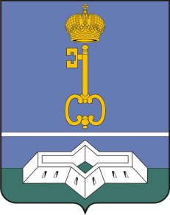

Short summary of the project

People are the main priority of every municipality. Happy people are those people who can fill the desire for creative expression in literature or in art. In all three municipalities,Vilani, Karsava and Shlisselburg, there exist professional literary and artistic groups thoughtheir activities take place in a very narrow circle. Implementation of this project and coordination of these groups in different organizations will break down borders between people on the local and international level. To achieve optimum results project partners will apply existing potential of the territory - cultural centres and historical cooperation ties.

Implementation of the project will involve more than 3000 people (literary people, artists, library users). They will get improved places of public use: open-air reading space -stage near the Vilani library, open-air stage in Karsava and renovated library in Shlisselburg. New, stronger international literary and artistic group will introduce the final products (a blog and a book) to wider audience and will attract new participants to their groups thus making a solid basis for sustainability of the project results.

Overall objective

To develop in Vilani, Karsava and Shlisselburg a united cultural information environment and collaboration network used by people with literary and artistic creative potentialin order to achieve stronger cooperation between Latvian and Russian border municipalities.

Specific objective

- To provide Vilani, Karsava and Shlisselburg inhabitants with a possibility to expand literary and artistic skills and to make new opportunities for those who dare not show their talent to wider audience.
- To provide artistic and literary groups with a new improved places where their activities can be held and shown to the public
- To help literary and artist groups to create a ready product (blog and book) to advertise their actions and involve new participants.

Beneficiary

Vilani Local Municipality(Latvia)

Partners

Karsava Local Municipality(Latvia)
Administration of Municipal Formation Shlisselburg Town(Russia)

Expected results

- Infrastructure and environment improvement:
- Open-air reading space -stage near the library in Vilani
- Open-air stage in park for cultural events in Karsava
- Renovation of library in Shlisselburg
- Equipment purchase: computers and multimedia equipment for library users (more than 2600 people), laptops for outdoor reading space (Vilani), and open-air stage (Karsava). Multimedia equipment will be successfully used inthe teleconferences for poetry days and other cultural events.
- Literary and artistic groups potential strengthening:
- International Competition organized via multimediatele-communicative equipment (with about 300 participants) in all three municipalities at once to choose 30 best poems which will be published in an international book of art and poetry “Forget a Hurry”
- 5 days Summer camp "Art Recognizes no Borders" for new artists and literary people, with professional advice available (about 30 participants)
- New blog on literature and art
- 3 international Literature and Art meetings and 3 local Literature Meetings (about 45 participants)

Final beneficiaries

- Inhabitants of Municipality of Vilani, Municipality of Karsava and Municipality of Shlisselburg
- Literary and artistic groups in each municipality
- Libraries users

Duration

18 months

Budget

Total budget: 200 000, 00EUR
Programme co-financing: 171000, 00EUR (86%) Project co-financing: 29000, 00EUR (14%)

Contact Person

MsIvetaPiziča iveta.pizica@vilani.lv/ +371 29336050

